**NAAN MUDHALVAN – PROFESSIONAL READINESS FOR**

**INNOVATION, EMPLOYMENT AND ENTERPRENEURSHIP**

**ASSIGNMENT – 2**

|  |  |
| --- | --- |
| **STUDENT NAME** | KAVINISHA A |
| **STUDENT ROLL NO** | 814720104026 |

**QUESTION:**

Build wowki product, use ultrasonic sensor and detect the

distance from the object. Whenever distance is less than

100cms upload the value to the ibm cloud.in recent device

events upload the data from wokwi.

○ Example: distance is 20 cms. Upload the 20 value to the

ibm cloud in recent event in the ibm iot platform device

○ Submit the Assignment in PDF format in the Git repo.

○ PDF should have wokwi share link, connections image,

code, IBM cloud recent events image(Screenshot)

○ Everyone in the team should submit the assignment as

it is an individual task.

**LINK:**

**https://wokwi.com/projects/365251094093627393**

**Code:**

#include <WiFi.h>//library for wifi

#include <PubSubClient.h>//library for MQtt

#define LED 5

#define LED2 4 #define

LED3 2 int LDR = 32; int

LDRReading = 0; int

threshold_val = 800;

int lEDBrightness = 0;

int flag=0;

void callback(char* subscribetopic, byte* payload, unsigned int

payloadLength);

//-------credentials of IBM Accounts------

#define ORG "stuloy"//IBM ORGANITION ID

#define DEVICE_TYPE "abcd"//Device type mentioned in ibm watson IOT Platform

#define DEVICE_ID "1234" //Device ID mentioned in ibm watson IOT Platform

#define TOKEN "12345678" //Token

String data3; float h, t;

//-------- Customise the above values -------- char server[] = ORG

".messaging.internetofthings.ibmcloud.com";// Server Namechar publishTopic[] =

"iot-2/evt/Data/fmt/json";// topic name and type of event perform and format in which data to be send charsubscribetopic[] = "iot-2/cmd/test/fmt/String";//

cmd REPRESENT command type AND COMMAND IS TEST OF FORMAT STRING char

authMethod[] = "use-token-auth";// authentication method char token[] = TOKEN;

char clientId[] = "d:" ORG ":" DEVICE_TYPE ":" DEVICE_ID;//client id

//-----------------------------------------

WiFiClient wifiClient; // creating the instance for wificlient

PubSubClient client(server, 1883, callback ,wifiClient); //calling the predefined

client id by passing parameter like server id,portand wificredential void

setup()// configureing the ESP32

{

Serial.begin(115200);

pinMode(LED,OUTPUT);

pinMode(LED2,OUTPUT);

pinMode(LED3,OUTPUT);

delay(10);

Serial.println();

wificonnect();

mqttconnect();

} void loop()// Recursive

Function

{

//PublishData(t, h);

//delay(1000);

/* LDRReading = analogRead(LDR);

Serial.print("LDR READING:");

Serial.println(LDRReading);

if (LDRReading >threshold_val){

lEDBrightness = map(LDRReading, 0, 1023, 0, 255);

Serial.print("LED BRIGHTNESS:");

Serial.println(lEDBrightness);

analogWrite(LED, lEDBrightness);

analogWrite(LED2, lEDBrightness);

analogWrite(LED3, lEDBrightness);

} else{

analogWrite(LED, 0);

analogWrite(LED2, 0);

analogWrite(LED3, 0);

}

delay(300);*/

if (!client.loop()) {

mqttconnect();

}

}

/*.....................................retrieving to

Cloud...............................*/

/*void PublishData(float temp, float humid) {

mqttconnect();//function call for connecting to ibm*/

/* creating the String in in form JSon to update the data to ibm

cloud */

/*String payload = "{\"temperature\":";

payload += temp; payload += ","

"\"humidity\":"; payload += humid;

payload += "}";

Serial.print("Sending payload: ");

Serial.println(payload);

if (client.publish(publishTopic, (char*) payload.c_str())) {

Serial.println("Publish ok");// if it sucessfully upload data on the cloud

then it will print publish ok in Serial monitor or else it will print publish

failed

} else {

Serial.println("Publish failed");

}

} */ void mqttconnect()

{ if (!client.connected())

{

Serial.print("Reconnecting client to ");

Serial.println(server);

while (!!!client.connect(clientId, authMethod, token)) {

Serial.print("."); delay(500);

}

initManagedDevice();

Serial.println();

} }

void wificonnect() //function defination for wificonnect

{

Serial.println();

Serial.print("Connecting to ");

WiFi.begin("Wokwi-GUEST", "", 6);//passing the wifi credentials to establish

the connection while (WiFi.status() != WL_CONNECTED) { delay(500);

Serial.print(".");

}

Serial.println("");

Serial.println("WiFi connected");

Serial.println("IP address: ");

Serial.println(WiFi.localIP());

} void

initManagedDevice() {

if (client.subscribe(subscribetopic)) {

Serial.println((subscribetopic));

Serial.println("subscribe to cmd OK");

} else {

Serial.println("subscribe to cmd FAILED");

}

} void callback(char* subscribetopic, byte* payload, unsigned int

payloadLength)

{

Serial.print("callback invoked for topic: ");

Serial.println(subscribetopic);

for (int i = 0; i < payloadLength; i++)

{ //Serial.print((char)payload[i]);

data3 += (char)payload[i];

}

Serial.println("data: "+ data3);

if(data3=="lighton1")

{

Serial.println(data3); digitalWrite(LED,HIGH);

} else

if(data3=="lightoff1")

{

Serial.println(data3);

digitalWrite(LED,LOW);

}

else if(data3=="lighton2")

{

Serial.println(data3);

digitalWrite(LED2,HIGH); } else

if(data3=="lightoff2")

{

Serial.println(data3); digitalWrite(LED2,LOW);

} else

if(data3=="lighton3")

{

Serial.println(data3);

digitalWrite(LED3,HIGH);

} else

if(data3=="lightoff3")

{

Serial.println(data3); digitalWrite(LED3,LOW);

}

data3="";

}

**CIRCUIT DIAGRAM:**

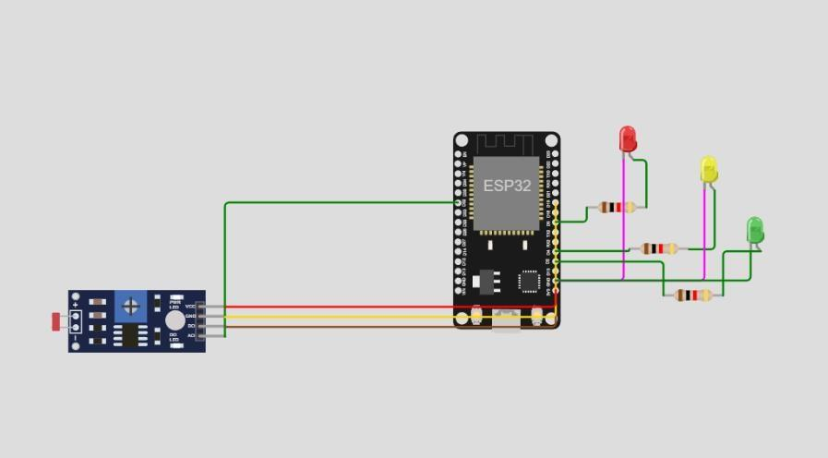

**IBM CLOUD RECENT EVENT IMAGE:**

